**Señora Roldan’s “Ser” finger family song**

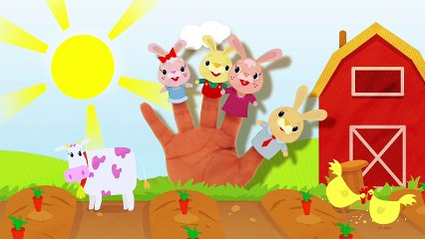

Yo soy yo soy means I am

Yo soy yo soy means I am

Tú eres tú eres you informal are

Tú eres tú eres you informal are

Él es, Ella es, u-sted es

MC910217272[1]He is, she is, you formal are

Nosotros somos, nosotros somos we masculine are

Nosotras somos, nosotras somos we feminine are

Vosotros sois, vosotros sois you all are

Vosotras sois, vosotras sois you all are

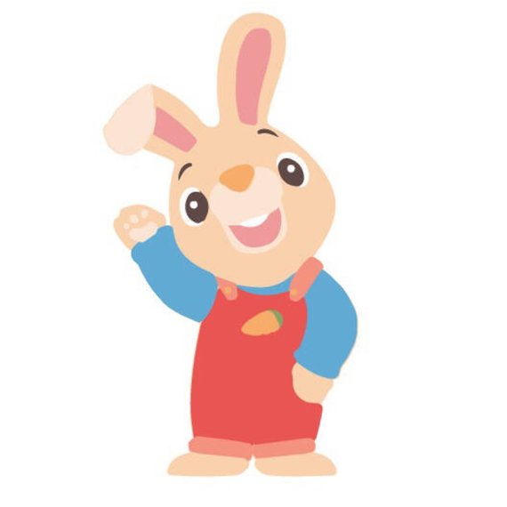

Ellos son, ellas son, ustedes son

They are, they are, you all formal are

**\*\* Ser is a verb; an action word.**

**\*\* Ser means to be.**

**\*\* Ser when conjugated becomes soy, eres, es, somos, sois, son.**

**\*\* Ser conjugations in English are translated: am, is, are.**