COLORS SONG!
To ask someone their favorite color:
¿Cuál es tu color favorito?
¿Qué color es tu favorito?
To respond:
Mi color favorito es …. (color) (ex: Mi color favorito es amarillo.)
Mis colores favoritos son (more than 1 color)
(example: Mis colores favoritos son amarillo y verde.)
Amarillo is the sun do-dah, do-dah
Anaranjado is an orange oh –do-dah-day

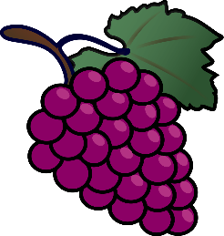
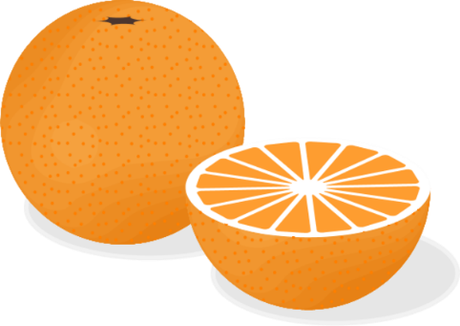
Verde is the grass
Azul is the sky
Negro is a witch’s hat
Café is chocolate pie
Amarillo is the sun do-dah, do-dah
Anaranjado is an orange oh –do-dah-day
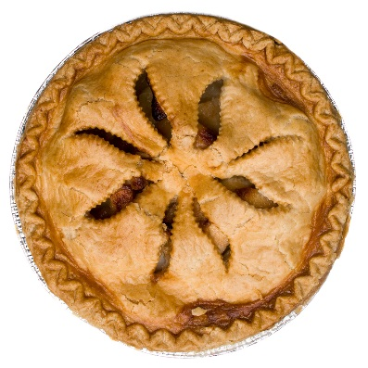
Rojo is a rose
Blanco is the snow
morado is a bunch of grapes
Rosado is bubble gum
and gris is an elefante

