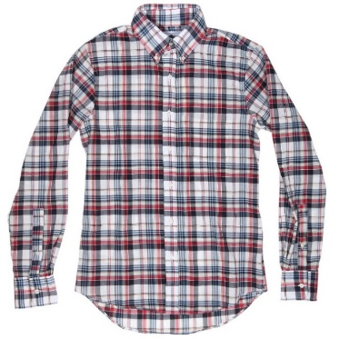
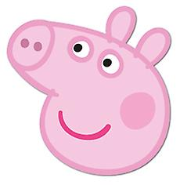
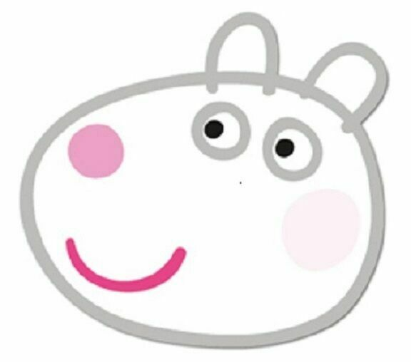
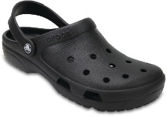
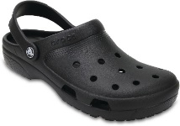
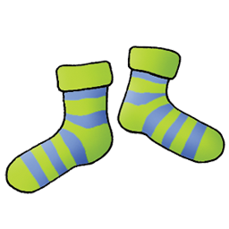
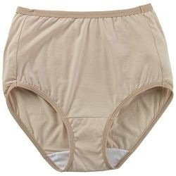
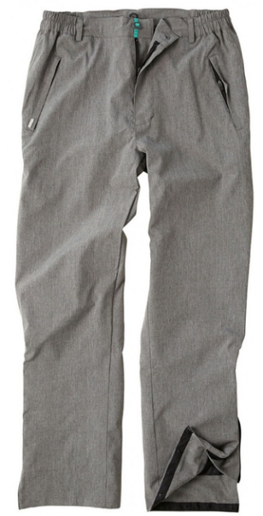
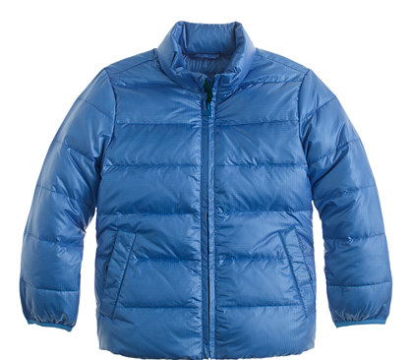
Camisa means shirt
Camisa means shirt
Hi ho get ready to go
Camisa means shirt
Calcetines socks
Calcetines socks
Hi ho get ready to go
Calcetines socks
Ropa interior - gasp underwear
Ropa interior - gasp underwear
Hi ho get ready to go
Ropa interior - gasp underwear
Pantalones pants
Pantalones pants
Hi ho get ready to go
Pantalones pants
Abrigo coat
Abrigo coat
Hi ho get ready to go
Abrigo coat
Zapatos shoes
Zapatos shoes
Hi ho get ready to go
Zapatos shoes
Sombrero hat
Sombrero hat
Hi ho get ready to go
Sombrero hat
Hi ho get ready to go
Sombrero hat
¡Listo/a!
Pick a head & move it here!
Hi ho get ready to go!

